Welcome to Montpellier

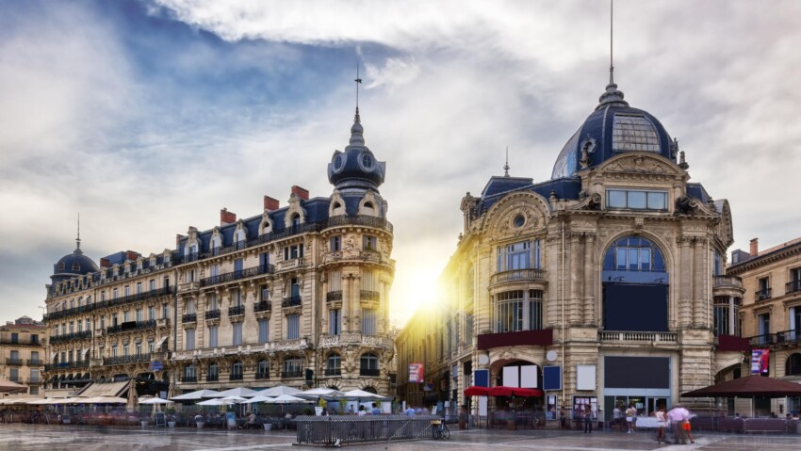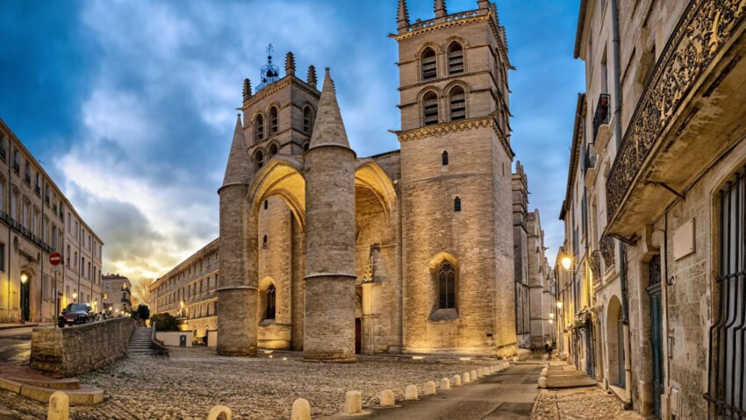

We are delighted to welcome you at the University of Montpellier for your participation in the Montpellier Global Days!

We hope that the conference you will attend will pave the way to fruitful discussions, great networking, and enriching experiences that will stimulate your research and scientific career.

This document contains general information, tips and logistical details to facilitate your stay in Montpellier.

Program
Dates | Monday 22/06 | Tuesday 23/06 | Wednesday 24/06 | Thursday 25/06
Venue |  | University of Montpellier | Botany Institute University of Montpellier | Appart City Hotel
Morning |  | Visit of Michelin star ecodining restaurant  Visit of UM botanical garden | Scientific conferences  - Wine and Vine  - Sea shells  - Poster session during breaks | Departure
Lunch |  | Belaroia Restaurant | Botany Institute Buffet | Departure
Afternoon | Train from Barcelona train station  Group departure 16:24 | Visit of the Old medical school faculty  Poster Installation  Free time | Scientific Conferences  - Rice  - Coffee  - Poster session during breaks | Departure
Night | Arrival in Montpellier at 19:42  Dinner at Chez Delagare 20:30 | 18:30 : Montpellier Global Days Opening Ceremony | 18h: Closing Cocktail Ceremony and Best Poster Prize  20h30: Dinner at Belaroia | Departure

Accommodation
- You will be staying at Appart City Centre Montpellier Gare Saint Rochat, located, 20 rue de la République, 34000 Montpellier for the period 22-25 June 2026.
- Accommodation is organized on the basis of double room occupancy. You will be sharing a room with a fellow student
- Breakfast is included in your booking
- Each apartment is equipped with a kitchen to allow you to heat up your meals and/or cook if you wish so

Meals
All meals are provided during your stay, either at the restaurant Chez Delagare (within the Belaroia hotel across the street) or at the Botany Institute during the MGD conference. As mentioned previously, breakfast is included with your booking at Appart City Centre Montpellier Gare Saint Roch .

- Lunch:
  - 23 June: Restaurant Chez Delagare – Hotel Belaroïa
  - 24 June: MGD Conference, University of Montpellier Botany Institute Hall
  - 25 June: Restaurant Chez Delagare – Hotel Belaroïa* Reserved to cohort 2 members leaving by train and/or flight on the afternoon of the 25
- Dinner:
  - 22 and 24 June: Restaurant Belaroïa
  - 23 June: MGD Opening Ceremony, University of Montpellier Botanical Garden
Map from hotel to Restaurant Chez de la Gare (2 min walk)
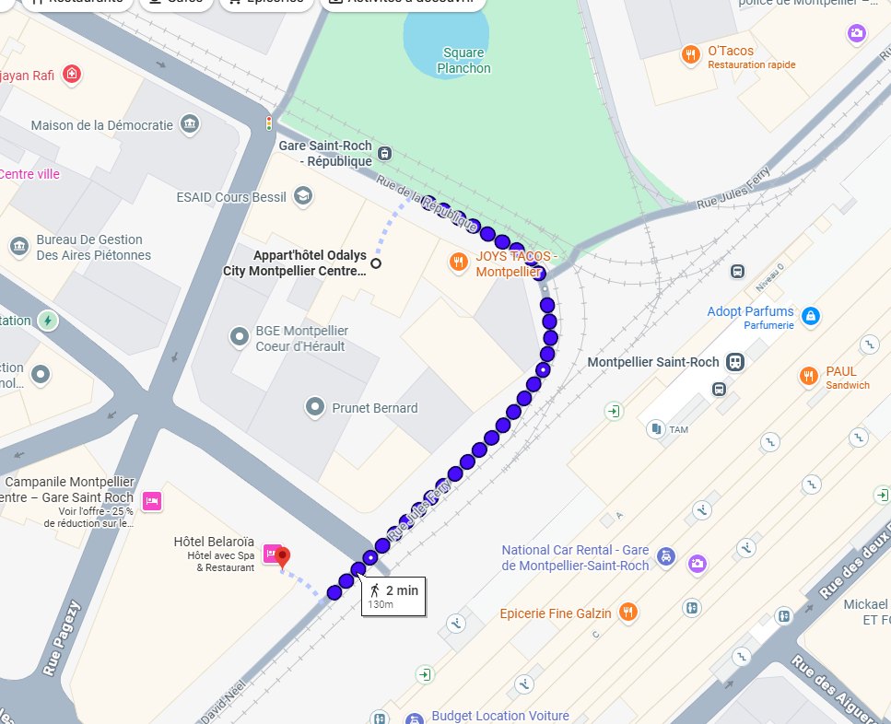

Meeting venues

- Montpellier Global Days Conference: University of Montpellier, Botany Institute, 163 rue Auguste Broussonet – 15-20 minutes’ walk from the hotel.
Map from Appart City to Plant Garden/Botany Institute (15 min walk plant garden, 20 minutes botany institute)
- 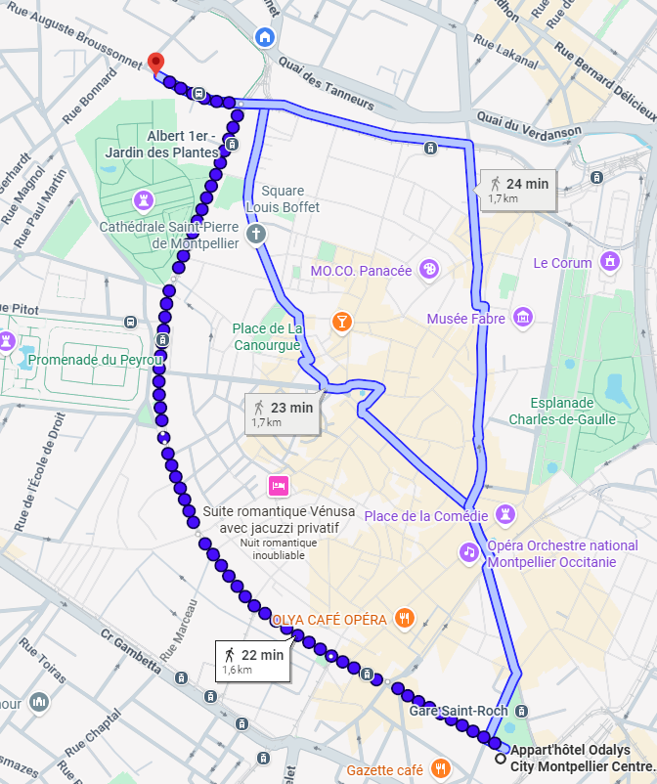

Transportation in Montpellier

- Upon arriving in Montpellier
  - The whole group will arrive at Saint Roch train station: the hotel is accross the street of the train station. Elsa Denis will guide you.
- Leaving Montpellier
  - From Appart City to Montpellier airport: transfer via private-chartered minibus has been arranged. The chauffeur will wait for you in the lobby 2 and a half hours before your flight (exact meeting time will be provided). Please be punctual
  - From Apart City to the Montpellier Sud-de France train station: the blue tram line 1 direction “Gare Sud de France” (1 min walk from hotel) will take you directly to the train station in 25 minutes. Tram tickets will be provided for those concerned.
  - From Apart City to the Montpellier Saint Roch train station: under 5 minutes’ walk from the hotel.

- Getting around Montpellier
Your hotel being in the center of Montpellier, you can walk around the city very easily. If you wish to go further in your free time, you can download the App M’Ticket Tam and purchase Daily or single tram tickets.
- Please use this website to plan your Tram journeys : TaM - Transports de Montpellier Méditerranée Métropole - Recherche d’itinéraire – TaM Transports de l’agglomération de Montpellier - Formulaire de recherche (tam-voyages.com)

- Please use this website to visualize the tram map: TaM - Plan interactif du réseau de transport de Montpellier (tam-voyages.com)

- Itineraries by tram:
- To the conference site: Line 4, direction Garcia Lorca (B), get off at Place Albert 1er-Cathédrale stop (3 stops)
- To Sud-de-France train station: Line 1, direction Gare Sud-de-France, get off at the terminus, Gare sud de France.

Emergency numbers EU and France
- All emergencies (unique European number): 112
- Medical emergency: 15
- Police: 17
- Firefighters: 18
- Medical centers: Jean Bouyer on-call medical center, 2 Rue des Tourterelles, 34090 Montpellier – Phone +33 (0)4 67 06 04 64
- UM safety officers n°: Elsa Denis +33 (0)7 71 84 52 82 (WhatsApp) / + 33 7 67 97 74 28 (phone) – Nathalie Modjeska +33 (0)6 25 45 32 37 – Karen Lambert-Cordillac : +33 (0)6 25 92 60 70

Visiting Montpellier

What is the climate like in Montpellier in June?
Generally, the climate in Montpellier in June is very warm (average temperatures ranging around 30° C).

Do I need an adapter to travel to Europe?
France has adopted type C, E, and F sockets. All of these sockets have 2 pins and support a voltage of 220 to 240 volts, with an amperage of 2.5 amps for type C sockets and 16 amps for type E and F sockets. Depending on where you come from you might need an adapter.

Some information about Montpellier
Montpellier is a dynamic and attractive city, a millennial city that combines significant historical heritage with beautiful contemporary architectural achievements. With its 13 research centers, two universities, and six higher education institutions, the city is highly sought after by students, who represent more than 20% of its population.
You can stroll through its medieval streets and explore its new neighborhoods that combine natural spaces with constructions signed by the greatest international architects. As the capital of the art of living, Montpellier opens onto the Mediterranean.
The sea is only a few kilometers away, accessible by tram and bus from the city center. In the background, the reliefs of the Cévennes, including Pic St Loup, stand out when the weather is clear, visible from the gardens of Peyrou, right in the heart of the city.

What to see in Montpellier?
Place de la Comédie
The beating heart of the city, the Place de la Comédie is one of the largest pedestrian areas in Europe. It is home to two iconic landmarks: the Opéra Comédie, an Italian-style theater from 1888, and the statue of the Three Graces atop the fountain.
This square is the perfect starting point to discover the city, as it is at the heart of the tram network with a stop where lines 1 and 2 converge. You can also enjoy the sun by having a drink on the terraces of its many cafes and restaurants.
Just a stone's throw from the Comédie, on the way to the Palais des Congrès Le Corum, discover the Fabre Museum and its collections that take you on an artistic journey through the centuries, and the Pavillon Populaire, a space for photographic art.

L'Écusson
L'Écusson is the name given to the historic center of Montpellier, characterized by its contour in the shape of an ancient French shield, resembling a pentagon. In the past, a drawbridge, at the level of the Peyrou gate, allowed entry into the Écusson. Even today, the Babote tower, which you can see next to the tram stop "Observatoire," is a testimony to the fortifications that protected Montpellier in the 12th century.
From the Place de la Comédie to the royal square of Peyrou, take a walk in the Écusson, a completely pedestrianized city center. Head towards Place de la Canourgue, overlooking Saint-Pierre Cathedral and its monumental porch. Continue on Rue Foch for its perspective on the Arc de Triomphe, then on to Place Royale du Peyrou and the Saint-Clément aqueduct, with a breathtaking view of the Arceaux district. A piece of advice, keep your eyes open and discover, by chance through a partially open door, one of the wonderful courtyards of private mansions, jewels of Montpellier architecture.

Faculty of Medicine (Planned visit on Tuesday 23 June)
Founded in the 12th century, the Faculty of Medicine of Montpellier is the oldest active faculty of medicine in Europe. It has hosted scholars and scientists from all eras and origins. Thus, Rabelais, Lapeyronie, Chaptal, Arnaud de Villeneuve, and Guy de Chauliac have all left their mark on its history.

Jardin des plantes (Planned visit on Tuesday 23 June)
Boulevard Henri IV, 34000 Montpellier
Founded in 1593 by Henri IV, France's oldest botanical garden covers almost 5 hectares in the heart of Montpellier. Attached to the Faculty of Medicine, this space once entirely dedicated to research and teaching continues to attract researchers from all over the world. Since February 12, 1982, the Jardin des Plantes de Montpellier has been listed as a site. It has been protected as a Historic Monument since September 3, 1992.
The city’s botanical garden is located right next to the venue of your training sessions. Make sure to go and stroll in the shade of the bamboo grove or along the shady paths of the English garden, admire the Martins greenhouse and its "succulent" plants, or dream along the banks of the lotus pond in the footsteps of André Gide or Paul Valéry. Jardin des plantes - Université de Montpellier (umontpellier.fr)

Avant-garde architecture in Montpellier
If you wish to delve further into architectural marvels, head to Antigone, a neighborhood built in the 1980s by Ricardo Bofill. Since then, Montpellier has become a city at the forefront of architecture in France.
Arriving at Esplanade de l'Europe, you will be surprised by the Arbre Blanc (White Tree) by Sou Fujimoto, with its balconies hanging over the void. Along the Lez, a coastal river that runs through Montpellier, head towards Port Marianne. This new neighborhood was designed by renowned contemporary architects around the Jacques Cœur basin. You will discover the city hall, a huge blue and black cube designed by Jean Nouvel and François Fontès.
A little further along the tram line, you will see the RBC design center, called "the Cloud," a space designed by Philippe Starck. Closeby, the Odysseum complex offers a range of leisure activities, including an aquarium and planetarium.

Except for Montpellier residents

